Please see this weeks update.

For ease of reading all significant updates are highlighted in red.

As of Monday 20th April, sealing will recommence downstream from where the sheep pens are situated (as shown in image below marked with red circle):

There will be a total of 5 tankers on site alongside a supervisor and a Southern Water technician.

At this time no traffic management is required. Please be assured that once it is we will let you know when and where it will be placed.

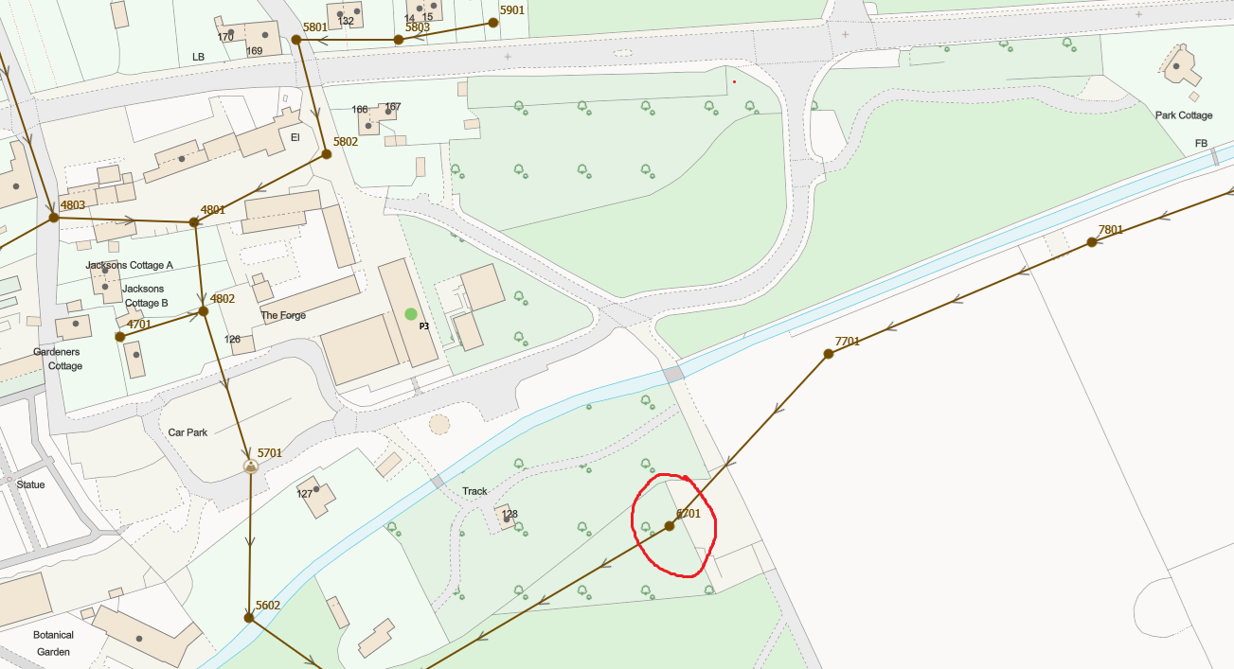

In my last update I said that we were going to survey all the sealing that has been undertaken and am pleased to let you know that this has started.

Once this is complete, we will discuss a remedial plan with our manhole sealing team to reduce infiltration that is entering the network via the private inspection chambers we identify.
At this stage, we have not identified any failed sewer sealing works.
Progress Update:
- The total sealed to date remains the same at around 12,291m across both public and private sewer networks.

Aside from the above, it’s business as usual as we continue progressing with the task at hand.

I've also included the borehole data from Chilgrove below which shows the ground water levels for your reference.

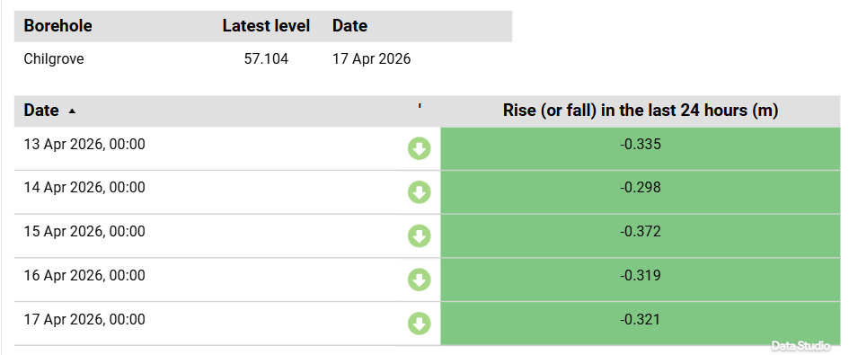

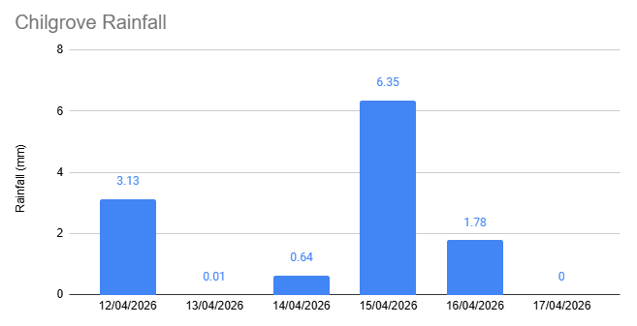

The ground water continues to fall and we will monitor this to find more localised issues created by this years ground water season.

We will continue to investigate and fix as we find the issues as quickly as possible to get the tankers away from the catchment.

